PLOS ONE

**Climatic Risk Factors for the Transmission of Dengue Fever: Bangladesh Perspective**

--Manuscript Draft--

|  |  |
| --- | --- |
| **Manuscript Number:** | PONE-D-23-15182 |
| **Article Type:** | Research Article |
| **Full Title:** | Climatic Risk Factors for the Transmission of Dengue Fever: Bangladesh Perspective |
| **Short Title:** | Climatic Risk Factors for the Transmission of Dengue Fever |
| **Corresponding Author:** | Md Rezaul Karim Jahangirnagar University  Savar, Select an option… BANGLADESH |
| **Keywords:** | Bayesian Inferences; Markov Chain Monte Carlo; Gibbs sampling; Dengue; Bangladesh |
| **Abstract:** | Dengue fever has become a major global public health concern. A significant global public health risk is dengue disease. Predicting how climatic factors will affect the spread of vector-borne diseases is difficult. However, the link is non-linear, geographically localized, and involves considerable lag periods between predictors and disease outbreaks. This disease spreads swiftly in Bangladesh due to its dense population and complex health policy setting. It is crucial to investigate the impact of climatic risk factors on Dengue transmission because it is an infectious disease spread by mosquitoes. In anticipating the occurrence or extent of each dengue outbreak, the methodology integrates confirmed Dengue cases and seasonal variables such as precipitation, temperature, humidity, wind speed, and lag duration of up to two years.  The main objective is to examine how climatic risk variables affect dengue epidemics using Bayesian inference. Bayesian inference is drawn using MCMC with Gibbs sampling, which is carried out in the WinBUGS software. According to the study, less precipitation reduces infected cases and fatalities from Dengue. Furthermore, the spread of Dengue has diminished due to high temperatures, which have also affected the virus’s ability to survive and spread. |
| **Order of Authors:** | Md Rezaul Karim |
| Nazmin Akter, MS |
| **Additional Information:** |  |
| **Question** | **Response** |
| **Financial Disclosure**  Enter a financial disclosure statement that describes the sources of funding for the work included in this submission. Review the [submission guidelines](http://journals.plos.org/plosone/s/submission-guidelines#loc-financial-disclosure-statement) for detailed requirements. View published research articles from [*PLOS ONE*](http://journals.plos.org/plosone/) for specific examples.  This statement is required for submission and **will appear in the published article** if the submission is accepted. Please make sure it is accurate. | Yes, We received fund from Jahangirnagar University |

*Powered by Editorial Manager® and ProduXion Manager® from Aries Systems Corporation*

|  |  |
| --- | --- |
| **Unfunded studies**  Enter: *The author(s) received no specific funding for this work.*  **Funded studies**  Enter a statement with the following details:   * Initials of the authors who received each award * Grant numbers awarded to each author * The full name of each funder * URL of each funder website * Did the sponsors or funders play any role in the study design, data collection and analysis, decision to publish, or preparation of the manuscript? * **NO** - Include this sentence at the end of your statement: *The funders had no role in study design, data collection and analysis, decision to publish, or preparation of the manuscript.* * **YES** - Specify the role(s) played. |  |
| * typeset |
| **Competing Interests**  Use the instructions below to enter a competing interest statement for this submission. On behalf of all authors, disclose any [competing interests](http://journals.plos.org/plosone/s/competing-interests) that could be perceived to bias this work—acknowledging all financial support and any other relevant financial or non- financial competing interests.  This statement is required for submission and **will appear in the published article** if the submission is accepted. Please make sure it is accurate and that any funding sources listed in your Funding Information later in the submission form are also declared in your Financial Disclosure statement.  View published research articles from  [*PLOS ONE*](http://journals.plos.org/plosone/) for specific examples. | No |

*Powered by Editorial Manager® and ProduXion Manager® from Aries Systems Corporation*

|  |  |
| --- | --- |
| **NO authors have competing interests**  Enter: *The authors have declared that no competing interests exist.*  **Authors with competing interests**  Enter competing interest details beginning with this statement:  *I have read the journal's policy and the authors of this manuscript have the following competing interests: [insert competing interests here]* |  |
| * typeset |
| **Ethics Statement**  Enter an ethics statement for this submission. This statement is required if the study involved:   * Human participants * Human specimens or tissue * Vertebrate animals or cephalopods * Vertebrate embryos or tissues * Field research   Write "N/A" if the submission does not require an ethics statement.  General guidance is provided below. Consult the [submission guidelines](http://journals.plos.org/plosone/s/submission-guidelines#loc-guidelines-for-specific-study-types) for detailed instructions. **Make sure that all information entered here is included in the Methods section of the manuscript.** | Field Research |

*Powered by Editorial Manager® and ProduXion Manager® from Aries Systems Corporation*

|  |  |
| --- | --- |
| **Format for specific study types**  **Human Subject Research (involving human participants and/or tissue)**   * Give the name of the institutional review board or ethics committee that approved the study * Include the approval number and/or a statement indicating approval of this research * Indicate the form of consent obtained (written/oral) or the reason that consent was not obtained (e.g. the data were analyzed anonymously)   **Animal Research (involving vertebrate animals, embryos or tissues)**   * Provide the name of the Institutional Animal Care and Use Committee (IACUC) or other relevant ethics board that reviewed the study protocol, and indicate whether they approved this research or granted a formal waiver of ethical approval * Include an approval number if one was obtained * If the study involved *non-human primates*, add *additional details* about animal welfare and steps taken to ameliorate suffering * If anesthesia, euthanasia, or any kind of animal sacrifice is part of the study, include briefly which substances and/or methods were applied   **Field Research**  Include the following details if this study involves the collection of plant, animal, or other materials from a natural setting:   * Field permit number * Name of the institution or relevant body that granted permission |  |
|  |
| **Data Availability**  Authors are required to make all data underlying the findings described fully available, without restriction, and from the time of publication. PLOS allows rare exceptions to address legal and ethical concerns. See the [PLOS Data Policy](http://journals.plos.org/plosone/s/data-availability) and [FAQ](http://journals.plos.org/plosone/s/data-availability#loc-faqs-for-data-policy) for detailed information. | Yes - all data are fully available without restriction |

*Powered by Editorial Manager® and ProduXion Manager® from Aries Systems Corporation*

|  |  |
| --- | --- |
| A Data Availability Statement describing where the data can be found is required at submission. Your answers to this question constitute the Data Availability Statement and **will be published in the article**, if accepted. |  |
| **Important:** Stating ‘data available on request from the author’ is not sufficient. If your data are only available upon request, select ‘No’ for the first question and explain your exceptional situation in the text box. |
| Do the authors confirm that all data underlying the findings described in their manuscript are fully available without restriction? |
| **Describe where the data may be found in full sentences. If you are copying our sample text, replace any instances of XXX with the appropriate details.**   * If the data are **held or will be held in a public repository**, include URLs, accession numbers or DOIs. If this information will only be available after acceptance, indicate this by ticking the box below. For example: *All XXX files are available from the XXX database (accession number(s) XXX, XXX.*). * If the data are all contained **within the manuscript and/or Supporting Information files**, enter the following: *All relevant data are within the manuscript and its Supporting Information files.* * If neither of these applies but you are able to provide **details of access elsewhere**, with or without limitations, please do so. For example:   *Data cannot be shared publicly because of [XXX]. Data are available from the XXX Institutional Data Access / Ethics Committee (contact via XXX) for researchers who meet the criteria for access to confidential data.*  *The data underlying the results presented in the study are available from (include the name of the third party* | All relevant data are within the manuscript and its Supporting Information files. |

*Powered by Editorial Manager® and ProduXion Manager® from Aries Systems Corporation*

|  |  |
| --- | --- |
| *and contact information or URL).*   * This text is appropriate if the data are owned by a third party and authors do not have permission to share the data.   * typeset |  |
| Additional data availability information: |  |

*Powered by Editorial Manager® and ProduXion Manager® from Aries Systems Corporation*

[Click here to access/download;Manuscript;Paper.pdf](https://www.editorialmanager.com/pone/download.aspx?id=33290938&guid=927272b0-43ad-45dd-9b99-055be9439257&scheme=1)

**Journal Name manuscript No.**

(will be inserted by the editor)

**Climatic Risk Factors for the Transmission of Dengue Fever: Bangladesh Perspective**

# Md. Rezaul Karim · Nazmin Akter

Received: date / Accepted: date

# Abstract

Dengue fever has become a major global public health concern. A significant global public health risk is dengue disease. Predicting how climatic factors will affect the spread of vector-borne diseases is difficult. However, the link is non-linear, geographically localized, and involves considerable lag periods between predictors and disease outbreaks. This disease spreads swiftly in Bangladesh due to its dense population and complex health policy setting. It is crucial to investigate the impact of climatic risk factors on Dengue transmission because it is an infectious disease spread by mosquitoes. In anticipating the occurrence or extent of each dengue outbreak, the methodology integrates confirmed Dengue cases and seasonal vari- ables such as precipitation, temperature, humidity, wind speed, and lag duration of up to two years. The main objective is to examine how climatic risk variables affect dengue epidemics using Bayesian inference. Bayesian inference is drawn using MCMC with Gibbs sampling, which is carried out in the WinBUGS software. According to the study, less precipitation reduces infected cases and fatalities from Dengue. Furthermore, the spread of Dengue has diminished due to high temperatures, which have also affected the virus’s ability to survive and spread.

**Keywords** Bayesian Inferences · Markov Chain Monte Carlo · Gibbs sampling · Dengue · Bangladesh.

# Introduction

The Dengue virus, one of the viral pathogens, predominantly affects tropical and subtropical areas where it produces classical Dengue fever (DF) and Dengue Hemorrhagic fever (DHF). Dengue fever is a mosquito- borne disorder that affects millions of people each year [21,](#_bookmark30) [6]. The *Aedes aegypti* mosquito transmits Dengue illnesses. The *Aedes* mosquito may transmit the dengue virus without the need for an intermedi- ary animal vector. Often found in metropolitan areas, the *Aedes* mosquito maintains a man-mosquito-man interaction. Bangladesh is a country that suffers the most from dengue practically every year [2] and its tropical environment has made it an excellent place for the dengue virus to spread. Bangladesh witnessed occasional dengue virus transmission from 1964 to 1999, but The country is experiencing its worst dengue outbreak since 2000, with widespread dread of fatality as the illness spreads throughout the country, dis- proportionately impacting children, pregnant women, and the elderly [3,](#_bookmark12) [4,](#_bookmark13) [11,](#_bookmark20) [33] and mainly in the capital city of Dhaka. The country experienced its greatest epidemic in history in 2019, with over 100,000 reported illnesses and almost 120 deaths [14]. In the middle of the epidemic, the Directorate General of Health in Bangladesh recorded 1026 confirmed cases in 2020, and 20,000 in 2021 [14]. We again spotlight the dengue outbreak in Bangladesh in 2022, thus far is the third most cases reported in a year since the first cases were reported in 2000. The Ministry of Health & Family Welfare of Bangladesh has reported 52,807 laboratory-confirmed dengue cases overall as of 20 November 2022, with 230 deaths associated

Md. Rezaul Karim1

E-mail: [rezaul@juniv.edu](mailto:rezaul@juniv.edu)

Nazmin Akter1

E-mail: [nazmin.swarna194@gmail.com](mailto:nazmin.swarna194@gmail.com)

1 Department of Statistics, Jahangirnagar University, Bangladesh

1. Md. Rezaul Karim, Nazmin Akter

with the disease [1].

Dengue fever is common in tropical and subtropical regions, but the epidemic in Bangladesh war- rants additional investigation. What’s inflicting this unusual boom in dengue cases? The concept that weather modifications make it easier for illnesses to unfold to new populations has substantially height- ened humans’ worry approximately the arrival and reemergence of infectious diseases [26]. Bangladesh’s outbreak is being exacerbated by way of poor water, sanitation, and hygiene structures, in addition to a congested population, climatic trade, unplanned speedy urbanization, and building, poor vector manip- ulation strategies, and Bangladesh’s faltering healthcare gadget all contribute to the extent and severity of dengue epidemics [20,](#_bookmark29) [25,](#_bookmark34) [27,](#_bookmark36) [34,](#_bookmark43) [35]. Additional causes might be drainage issues, stagnant water and rubbish anywhere, weak immune reputation, bodily weak spot, unplanned market, wetland occupation, the habit of gardening, polluted waterbody, [13] and so on. Climate change increases the opportunity for Dengue epidemics as it strengthens the hyperlink between the vector and the virus [36,](#_bookmark45) [18]. The majority of research on this topic focuses on climate-related factors ( rainfall or humidity). This tendency may be detected in quite early studies, such as Moore’s [28], which showed that both the amount of rain and the persistence of rainfall were good predictors since when rainfall has continued to provide the most reliable early warning indicator [5]. Geographic location peak [5,](#_bookmark14) [30] and trough weather events, such as highest and lowest temperatures [30], abnormal climatic occurrence, and running averages [32] have all been added to the list of variables used in the literature. Choudhury et al. evolved a Seasonal Autoregres- sive incorporated transferring average (SARIMA) model, especially for Dhaka, Bangladesh. While this look stated that it does now not take into consideration weather elements, it does remember seasonality, which axiomatically captures primary climatic characteristics [10]. Karim et al. evolved models with the use of simple linear regression and Pearson’s correlation, utilizing a spread of environmental parameters including month-to-month rainfall, humidity, maximum, and lowest temperature, and determined that meteorological parameters may are expecting month-to-month dengue incidence with an excessive degree of accuracy [23]. However, the predictor variable glaringly deviated from the normal distribution. In some other studies, Kanchanapairoj, McNeil, and Thammapalo provided conflicting evidence that demonstrates the connection between dengue incidence and climatic situations is still up for debate [22]. Only a small amount of research has been executed so far on how weather influences the weight of ailment, appreciably dengue in South Asia.

The latest study, in addition to addressing the topic of climatic predictors of dengue in Bangladesh, employs a broader variety of statistical tactics. Statistically, it appears that most investigations utilized either very simple correlational techniques [12,](#_bookmark21) [19,](#_bookmark28) [23] or regression modeling [5,](#_bookmark14) [37], or both. We em- ployed the Bayesian Regression Method in this study. This generates a vast number of factors, including seasonal aspects, that allow researchers to investigate plausible links between scientifically quantifiable climate change and dengue transmission. Moreover, Bangladesh’s lack of preparedness, including weak public health infrastructure and ineffective vector-control programs, increases the impact of dengue virus importation, resulting in rising outbreaks. Anorexia, nausea, vomiting, pharyngitis, upper respiratory tract symptoms, relative bradycardia, prostration, depression, hyperesthesia, lymphadenopathy, and rash are some of the symptoms and signs of dengue [13]. Other symptoms and signs include fever, backache, arthralgia, headache, generalized pain, eye pain, lacrimation, scleral injection, and rash. Since 2000, med- ical professionals in Bangladesh have clinically identified dengue following WHO guidelines.

This study examines how key meteorological variables such as precipitation, heat, moisture, and wind speed may promote Dengue incidence in Bangladesh. Here, we present the findings of a study con- ducted across Bangladesh, using a Bayesian regression approach to estimate the prevalence of Dengue and pinpoint significant risk variables for infection. Following are the research’s main contributions. Then, using the Gibbs sampling (MCMC) algorithm to estimate the posterior distribution, future observations will be predicted. First, we will summarize measures for the location and variability of Dengue cases with additional risk factors and investigate the non-linear relationship between Dengue case counts and climatic factors for the dataset. To structure this article, there are four more sections. In Section 2, the fundamental formulation of the Bayesian model and the design of the Gibbs sampling technique, includ- ing the data sources, are discussed. In Section 3, the distributions for modeling daily Dengue cases are described, and the method’s application to a specific example of daily Dengue cases data is examined. Finally, Sections 4 and Section 5 give a general discussion and conclusion, respectively. In order to de- velop and provide a better knowledge of the complicated relationship between climate and health, this study aims to assess the impact of climatic risk variables on dengue incidence in Bangladesh. Health

Climatic Risk Factors for the Transmission of Dengue Fever: Bangladesh Perspective 3

professionals who create efficient plans to enhance public health may find this material to be useful.

# 2 Methods and Materials

Data Sources

The weather variables of temperature (measured in *◦* C), humidity (measured in %), precipitation (mea- sured in mm), and wind speed (measured in km/h) were collected from Bangladesh Meteorological De- partment. Data are available on the website [www.timeanddate.com/weather/bangladesh/dhaka/ext](http://www.timeanddate.com/weather/bangladesh/dhaka/ext). Daily dengue data were obtained from the Directorate General of Health Services (DGHS) of the Ministry of Health and Family Welfare [14].

Bayesian Poisson Regression

To represent discrete event counts that occur over predetermined intervals of time or space, the Poisson model can be employed. The Poisson model is especially useful when counts are right-skewed and cannot be reasonably approximated by a Normal model. Fitting a Bayesian Poisson regression model to the frequency of Dengue infected cases, say *Y* with density

*Yi*|*λi* ∼ Poission(*λi*)

where, *Yi* = 0*,* 1*,* 2*,* is the random variable and *λ* is the rate parameter, *λ >* 0.The mean and variance of

the density are generally known to be equal to *λi*. As a result, the typical value of *Y* should approximately reflect its variability given the predictors *X*. The Poisson regression model is defined as ([7]):

*E*(*Y* = *y/x*) = exp (*β*0 + *x*1*β*1 + *x*2*β*2) *. . . xpβp*) (1)

where *y* is the response variable, *x*’s are the independent variable, *p* is the number of independent variables and *β*’s are regression parameters.

*Likelihood Distribution*

Assume that *λi* can be expressed as a linear combination of *X* predictors, we can write

data: *Yi*|*β*0*, β*1*, β*2*β*3*, β*4 ∼ Poission(*λi*) with log(*λi*) = *β*0 + *β*1*X*1 + *β*2*X*2 + *β*3*X*3 + *β*4*X*4*.* (2)

where *β* represents the regression coefficients and *Xi*’s are the covariates as *Xi*= precipitation, temper- ature, humidity, wind speed. The likelihood function *Pr*(*Y* |*Xi, β*) = Poisson(*λi*). where, *Pr*(·|·) denotes a conditional probability function. The five parameters *β*0*, β*1*, β*2*, β*3*, β*4 is the intercept, precipitation, temperature, humidity and wind speed effect respectively.

*Specifying the Priors Distribution*

Assume the following prior distribution is applied to a parameter, where *π*(*.*) represents a prior distribu- tion.

*π*(*β*0) = uniform(0*,* 1) and *π*(*β*1)*.π*(*β*2)*.π*(*β*3)*.π*(*β*4) = normal(0*, σ*2)

To build the Bayesian model, we must express our prior knowledge of regression coefficients(*β*0*, β*1*, β*2*, β*3*, β*4). Again, using Normal priors makes sense because each of these coefficients can take on any value along the real line. We’ll also suppose that these priors—that is, our prior knowledge of the model coefficients—are independent. The complete Poisson regression model depiction of *Yi* is as follows.

prior: *β*0 ∼ U(0*,* 1)

*β*1 ∼ N(0*, τ*1) *β*2 ∼ N(0*, τ*2) *β*3 ∼ N(0*, τ*3) *β*4 ∼ N(0*, τ*4)

4 Md. Rezaul Karim, Nazmin Akter

where *τ*1*, τ*2*, τ*3*, τ*4 ∼ exp(0*.*1) are precision of priors (i.e.precision= 1/variance ). The posterior distribu- tion of *β*0*, β*1*, β*2*, β*3*, β*4 is determined by the likelihood function and prior distribution using the Bayes theorem.The likelihood and data-driven prior are multiplied to arrive at the posterior distribution. Con- sequently, we demonstrate the posterior distribution using the likelihood and prior distributions which are as follows:

*P* (*λ/Y* ) = exp[− Σ log *y* ! + *nY*¯ log *λ* − *nλ*] × √ 1

*n*

*i*

2*πσ*2

*i*=1

*x*2

exp[ ] (3)

2*σ*2

A prior is multiplied by a likelihood based on data to create the posterior distribution, which is then used as a prior in further modeling. Finally, these Bayesian probability distributions were employed for the data on Dengue cases in the Bayesian regression model.

Markov Chain Monte Carlo (MCMC) Method

The posterior inference result is increasingly difficult to assess and study the more variables we include in our model. The MCMC method is then utilized in this situation. The MCMC approach imitates the posterior in order to examine it. Inferences about the model and its parameters can then be made using the results. There are numerous MCMC approaches available. One of the most significant MCMC algorithms is the *Gibbs sampler*, which transformed Bayesian statistics and dramatically revived the Bayesian philosophy by offering solutions to real-world problems.

*Gibbs Sampling*

Using a combined probability distribution of two or more random variables, Gibbs sampling generates a series of samples as a form of probabilistic inference ([9]). In order to study the Gibbs distribution, the Gibbs sampler was first introduced in the context of image processing by [17]. The Gibbs sampler, on the other hand, didn’t become well-known in the statistical community until [15] showed that it could deal with complex estimating concerns in a Bayesian fashion.

The observable data (*Y* ) is the beginning condition for the Gibbs sampler. Gibbs sampling ne- cessitates the usage of an unnamed vector of pertinent variables. Gibbs sampling seeks estimates for the parameters of interest (*Y* ) to ascertain how well the observable data fits the model of interest and whether or not data independent of the observed data matches the model given by the observed data ([31]). The Gibbs sampler method does not compute the density before selecting random variables from a distribution. The Gibbs sampler needs very large sets (on the order of 15 or more sequences) for poorly preserved patterns to reach statistical significance ([31]). In order to avoid the considerably more challenging calculations, we can instead build a succession of simpler ones.

**Basic Algorithm of Gibbs Sampling:** Assuming a starting location *β*0 = (*β*0*, β*0*, β*0*, . . . , β*0)*T* ,The

0 1 2 *d*

multivariate Gibbs sampler uses an iterative technique, as seen below. The sampling process performs

the following *d* steps at iteration (*k* + 1):

1. Sample *βk*+1 from *p*(*β*0|*βk, βk, . . . , βk*

0

1

2

*d−*1

*, βk,* **y**);

1. Sample *βk*+1 from *p*(*β*1|*βk*+1*, βk, βk, . . . , βk,* **y**);

*d*

1

0

2

3

*d*

. . . . . . . . . . . . . . . . . . . . .

**(d).** Sample *βk*+1 from *p*(*βd*|*βk*+1*, βk*+1*, . . . , βk*+1*, βk*+1*,* **y**).

*d* 0 1

*d−*2

*d−*1

The conditional distributions *p*(*βj*|*βk, βk, βk, . . . , βk , βk , . . . , βk , βk,* **y**) are reffered to as full condi-

0

1

2

*j−*1

*j*+1

*d−*1

*d*

tional distributions, because *βj* depends on all other parameters.

The open-source MCMC application WINBUGS makes it straightforward to implement the Gibbs sampling algorithm. It can handle models with both common and unusual parameters because it is flexible enough. It can therefore be used in a variety of contexts, such as with insurance claim data, and is easy adaptable to enable more distributions (see [24]).

Climatic Risk Factors for the Transmission of Dengue Fever: Bangladesh Perspective 5

# Results

Exploratory Data Analysis

Table 1 and Figure 3 shows the daily mean rainfall, temperature, humidity, wind speed readings, and dengue incidence in Bangladesh, respectively. Dengue incidences in Bangladesh ranged from 0 to 1224 over a two-year period (1st January 2020 to 31st December 2021), with the peak incidence (1224 cases) occurring in December 2020. The daily mean precipitation ranged from 0 to 118 millimeters, with the maximum recorded measurement in April 2020. The daily mean temperature ranged from 15.10°C to 34.0

°C, with the maximum recorded temperature being in May 2020. The daily mean humidity ranged from 27% to 100%. The highest temperature ever recorded was in June 2021. The daily mean wind speed values ranged from 0.00 to 32.0 units. The fastest recorded speed occurred in May 2020. These findings indicate that all climatic parameters contribute to a conducive environment, increasing mosquito breeding and dengue transmission rates which is also supported by [30].

**Table 1** Descriptive statistics of Number of Dengue-infected people, precipitation, temperature, humidity, and wind speed for January 01, 2022, to 31 December 2022.

|  |  |  |  |  |  |
| --- | --- | --- | --- | --- | --- |
| Variables | Infected case | Precipitation | Temperature | Humidity | Wind speed |
| Mean (SD) | 274.80 (287.51) | 5.08 (12.26) | 26.94(4.23) | 73.67(15.06) | 4.02 (4.32) |
| Skewnwss | 1.69 | 4.11 | -0.73 | -0.64 | 2.10 |
| 25th Percentile | 41.50 | 0.00 | 23.50 | 63.50 | 1.00 |
| Median | 232.0 | 0.00 | 28.40 | 76.50 | 2.50 |
| 75th Percentile | 357.00 | 3.40 | 30.30 | 85.50 | 5.50 |
| 90th Percentile | 607.00 | 16.00 | 31.30 | 91.00 | 8.50 |
| 99th Percentile | 1209.00 | 59.10 | 32.65 | 97.35 | 19.50 |
| Min | 0.00 | 0.00 | 15.10 | 27.00 | 0.00 |
| Max | 1224.0 | 118.00 | 34.00 | 100.0 | 32.00 |

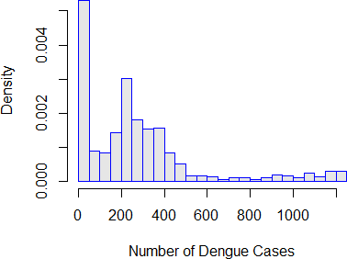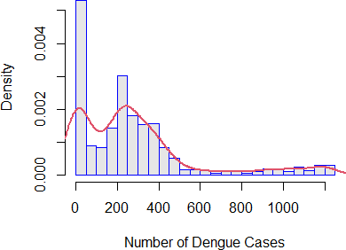

**Fig. 1** *(a).Histogram of Number of Infected Dengue Cases ; (b). Distribution of the number of Dengue Cases, during the period* 1*st January 2020–* 31*st December 2021.*

A kernel density plot of the infected dengue cases brought on by dengue fever is shown on a his- togram in Figure 1. It demonstrates that one of the most accurate probabilistic models for this variable is the bell-shaped distribution by showing that the number of confirmed Dengue cases appears to have a symmetric distributional form. It is hypothesized that a skewed distribution would be more accurate in forecasting the values of this variable based on a comparison of the distributional shape of the number of Dengue cases.

6 Md. Rezaul Karim, Nazmin Akter

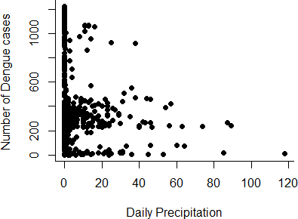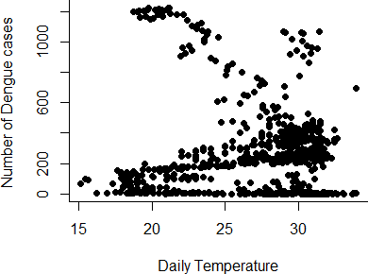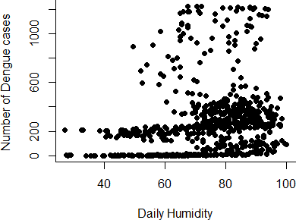

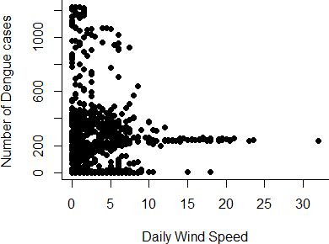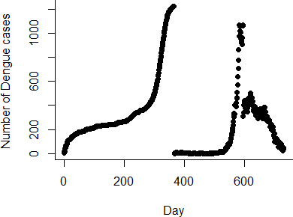

**Fig. 2** *Scatter diagram (a). The daily number of Dengue Cases vs. Daily Precipitation; (b). The daily number of Dengue Cases vs. Daily Precipitation; (c). The daily number of Dengue Cases vs. Daily Temperature; (d). The daily number of Dengue Cases vs. Daily Humidity; (e). The daily number of Dengue Cases vs. Daily Wind Speed during the period* 1*st January 2020–* 31*st December 2021.*

* 1. Bayesian Poisson Regression Model

To carries our Bayesian inference on the statistical problems using MCMC methods, we used the most popular Bayesian software. Three *WinBUGS* tools are required to obtain posterior samples: (a) the specification tool, (b) the sample monitor tool, and (c) the update tool. Since our model had four initial values, we set the *number of chains = 4* in order to get the appropriate posterior information. Further- more, the MCMC iteration is specified as 30*,* 000 in the update tool. In the sampling monitor tool, we specified *beg* from 10*,* 000 and ended with 30*,* 000 for updating the model. However the *thin* number was taken as 10 out there. We have got the summary statistics, trace, and density plot by clicking the option of these toolbars. The posterior summary measurements are displayed using the density and stat set- tings. Table 2 gives the sample, start iteration, posterior mean and SD, MC error, 2*.*5%*,* 50%*, and*97*.*5% posterior quantiles. Hence the estimated model is

log(*λi*) = 3*.*781−0*.*007×precipitation*i−*19 +0*.*015×temperature*i* +0*.*021×humidity*i* −0*.*037×wind speed*i.*

(4)

**Table 2** Summary statistics of the posterior distribution.

|  |  |  |  |  |  |  |  |  |
| --- | --- | --- | --- | --- | --- | --- | --- | --- |
| Parameter | mean | SD | MC error | 2*.*5% | median | 97*.*5% | start | samples |
| *β*0 | 3.781  -0.006777  0.01527  0.02116  -0.03779  15.22  14.84  15.2  14.83 | 0.02108  2.135*×*10*−*4  5.724*×*10*−*4  1.731*×*10*−*4  6.406*×*10*−*4  12.52  12.06  12.49  12.2 | 2.882 *×*10*−*4  2.568 *×*10*−*6  6.822*×*10*−*6  2.20*×*10*−*6  7.275*×*10*−*6  0.139  0.1311  0.1529  0.1445 | 3.74  -0.0072  0.01415  0.02082  -0.03906  1.1  1.153  0.9981  1.077 | 3.781  -0.006774  0.01527  0.02115  -0.0378  11.94  11.73  11.94  11.72 | 3.822  -0.006356  0.01639  0.0215  -0.03654  47.03  46.53  47.49  47.95 | 10000  10000  10000  10000  10000  10000  10000  10000  10000 | 8000  8000  8000  8000  8000  8000  8000  8000  8000 |
| *β*1 |
| *β*2 |
| *β*3 |
| *β*4 |
| *τ*1 |
| *τ*2 |
| *τ*3 |
| *τ*4 |

Climatic Risk Factors for the Transmission of Dengue Fever: Bangladesh Perspective 7

* + 1. *Interpreting the Posterior*

To simulate the Poisson posterior regression model, we employ MCMC trace graphs, density plots, and autocorrelation plots 4 and show that our simulation has stabilized. From 1 January 2020 to 31 December 2021, only nine posterior simulations of Dengue case data had ACF histograms with skew, range, and trend that match the observed data. Think about the precipitation coefficient *beta*1, which has a posterior median that is roughly -0.007. This suggests that we should expect roughly one time as much precipitation if it increases by one mm or 0.993% more, anti-discrimination laws: *e−*0*.*007 = 0*.*993 and the posterior median is around 0.015 for the temperature coefficient *beta*2. It implies that if the temperature rises by one unit, we might anticipate 1.02 times as many anti-discrimination measures, or 1.02 percent more: *e*0*.*0152 = 1*.*0153. The posterior median for the humidity coefficient *beta*3 is around 0.02115. This means that if the humidity increases by one unit, we should expect it to have 1.02 times as many, or 1.02 percent, more, likewise for the posterior median of the wind speed coefficient *beta*4, which is -0.0378. This means that if the wind speed increases by one km/h, we should anticipate 0.96 times as many, or 0.96 percent, more.

* + 1. *Graphically Checking*

Initially, the Markov chain distribution’s trace and autocorrelation plots were used to visually assess convergence. 10,000 iterations of each of the four chains were investigated. For all parameters except *beta*0, the trace plots 3 show a horizontal strip indicating stationarity and well mixing of the chains which indicates slow mixing of the chains.

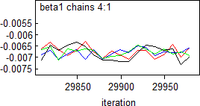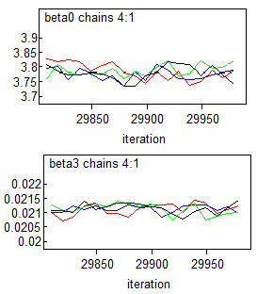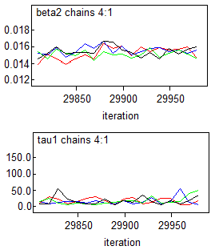Initially, convergence was evaluated visually using the trace and autocorrelation plots of the Markov chain distribution. We looked at 10,000 iterations of each of the four chains. The trace plots given in 3 display a horizontal strip suggesting stationarity and well mixing of the chains for all parameters except *beta*0, which indicates slow mixing of the chains. Furthermore, the autocorrelation plot 4 indicates that the current position of the chains does not predict the future position of the chains, indicating that the posterior distribution for parameters is extensively investigated. According to the autocorrelation plots in the 4, there is a decreased correlation between lengthy lags, which indicates that the chains were poor mixed.

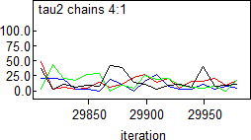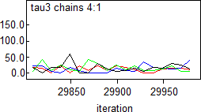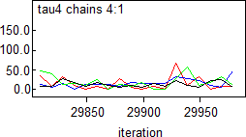

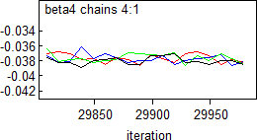**Fig. 3** *Trace plots of parameters (β) and variance of random effects*

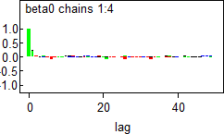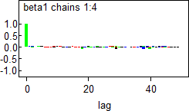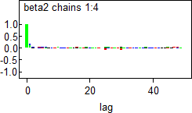8 Md. Rezaul Karim, Nazmin Akter

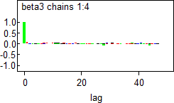 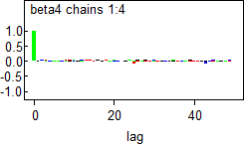 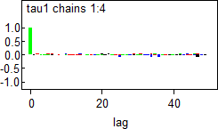

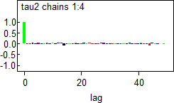 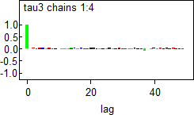 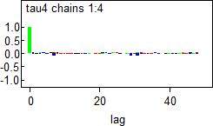

**Fig. 4** *Auto-correlation plots of parameters (β) and variance of random effects*

Formal Diagnostic Test

Three diagnostic tests are performed in order to confirm the stationarity, accuracy, and convergence: the Brooks-Gelman-Rubin (BGR) diagnostic approach developed by Geweke, HeidelbergerWelch, and. Table 3 details the official diagnostic tests for the 4 model with random intercept and slope.

**Table 3** Formal diagnostic tests for a bayesian regression model with random intercept and slope

|  |  |  |  |  |
| --- | --- | --- | --- | --- |
| parameter | Geweke | Heidelberger-Welch | BGR | effective sample size |
| Intercept (*β*0) | 0.285 | 0.850 | 1.000 | 3353.017 |
| Precipitation (*β*1) | 0.827 | 0.387 | 1.000 | 3000.000 |
| Temperature (*β*2) | 0.113 | 0.230 | 1.000 | 3816.157 |
| Humidity (*β*3) | -0.928 | 0.775 | 1.000 | 3000.000 |
| Wind Speed (*β*4) | 0.348 | 0.060 | 1.000 | 3000.000 |
| Deviance (*σ*2) | 1.425 | 0.567 | 1.000 | 3000.000 |

With default settings of 10% (first part of a chain) and 50% (second part of a chain), the Geweke diagnostic test demonstrated stationarity for all parameters with the exception of the estimated variance of the random intercepts, presuming that all *Z*-values for the parameters are constrained between -1.96 and 1.96. Heidelberger-diagnostic Welch’s also showed that every parameter passed the convergence test, leading to the conclusion that the length of the chain is sufficient to ensure the accuracy of the posterior means of the parameters. Figure 3 shows the Brooks-Gelman-Rubin (BGR) diagnostic, which is the sole convergence diagnostic test based on the four chains.

Poor chain mixing was discovered to be the cause of the huge sample size disparity between the effec- tive sample size and the MCMC simulation sample size (totaling 30,000). Additionally, it was found that *beta*2 had a large discrepancy, which suggested considerable autocorrelation. Significant results suggest non-randomness when evaluating the correlation between a variable’s most recent and previous values using autocorrelation.

For model evaluation purposes, different measures to check the model’s fit are shown in table 4. It is clear that the model has a larger posterior predictive value (PD), a discrepancy metric that indicates

Climatic Risk Factors for the Transmission of Dengue Fever: Bangladesh Perspective 9

complexity. In Table 4 *D*¯ stochastic parameters.

is the posterior mean of −2*logL* and *D*ˆ

= −2*logL* at a posterior mean of

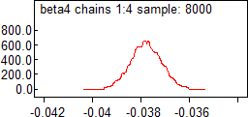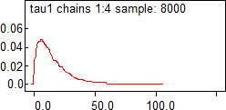**Table 4** Measure of fit for the Poisson regression model

|  |  |  |  |  |
| --- | --- | --- | --- | --- |
| Y | *D*¯ | *D*ˆ | *PD* | DIC |
| Cases | 186650.0 | 186645.0 | 5.123 | 186656.0 |
| Total | 186650.0 | 186645.0 | 5.123 | 186656.0 |

In figure 5, The model’s intercept, slope, and precision density plots are shown. The distribution of posterior information appears to be normally distributed.

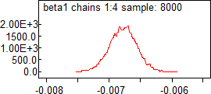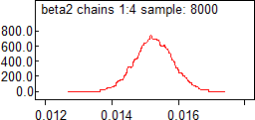

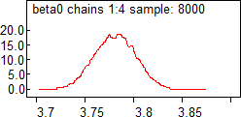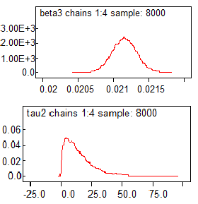

**Fig. 5** *Density plots for posterior distribution of parameters (β’s) and precision*

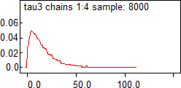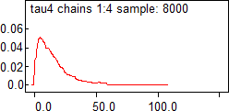In the history plot in figure 6, the well-mixed initials values have very small differences which indicates that the initial values of coefficients *βo, β*1*, β*2*, β*3*, β*4 got convergence.

# 4 Discussion

Dengue is a major hazard to public health and a significant economic burden in Bangladesh. An increasing body of evidence indicates that dengue imposes a massive socioeconomic cost on households, healthcare systems, and government health expenditures in endemic nations, particularly during outbreaks. An in- creasing number of initiatives are being made to relate relatively local-area factors like rainfall, humidity, and temperature to dengue incidence in order to increase public health relevance.

Since Dengue fever is a growing public health concern in Bangladesh, its identification of alterations in the climatic factor pattern will enhance case-finding from an environmental standpoint. Consequently, the purpose of this study was to provide insight into the altering climatic manifestation of dengue infec- tions in Bangladesh. In this study, we examined the effect of meteorological risk factors on the severity of dengue transmission using the dengue confirm cases. However, we must employ Bayesian methods such as Markov Chain Monte Carlo (MCMC) in order to use the informative prior ([16]). For Bayesian regression modeling, we built the Poisson regression model using the Normal distribution as the prior. The aim of Bayesian Regression is not to find the single “best” value of the model parameters but rather to determine the posterior distribution for the model parameters. Not only is the response generated

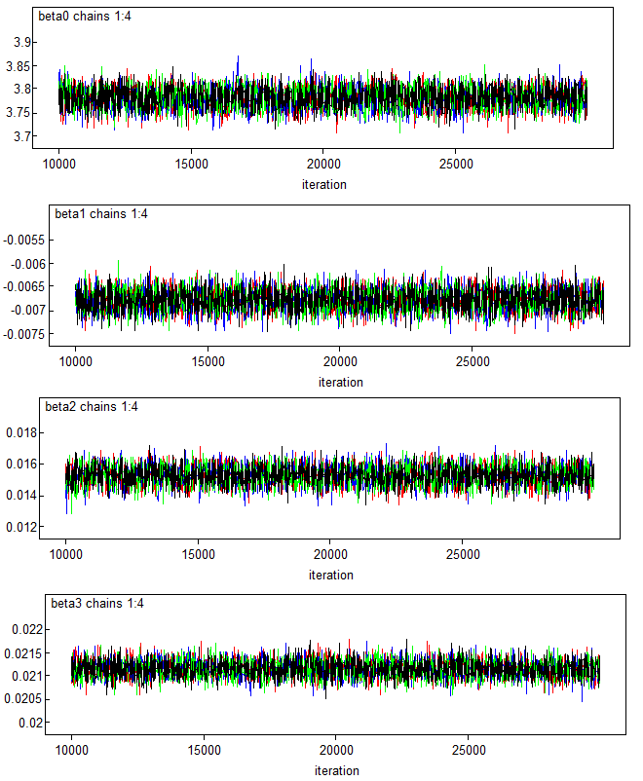10 Md. Rezaul Karim, Nazmin Akter

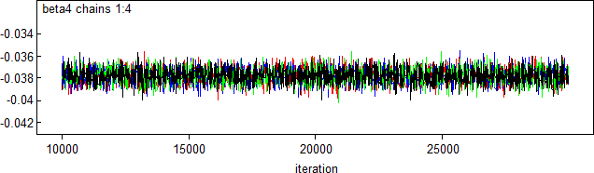

from a probability distribution but the model parameters are assumed to come from a distribution as well. In this respect, an attractive class of sampling algorithm, called MCMC method is explored to solve the practical problem in a Bayesian manner. This study demonstrated that the Gibbs sampling, a highly computationally efficient MCMC method [29], can generate accurate estimates of Bayesian regression coefficients for Dengue counts. In order to assess how well the observable data fits the model of interest and whether or not data independent of the observed data fit the model given by the observed data, Gibbs sampling is used to find estimates for the parameters of interest ([31]).

We proved the Bayesian discrete Poison model’s applicability to data on medical domain counts. We examined data on the total number of afflicted cases caused by Dengue fever in order to generate sta- tistical proof of the impact of climatic conditions on Dengue transmission. In the instances given, we concentrated on a daily count of all 731 Dengue causes from January 1, 2020, to December 31, 2021, which is discrete and has a right-skewed distribution, making the full conditional distribution of interest.

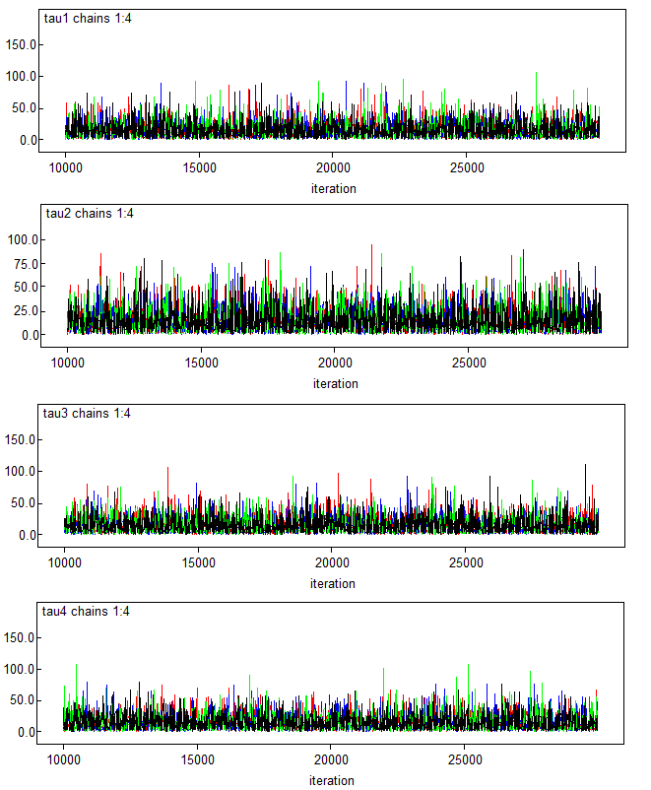Climatic Risk Factors for the Transmission of Dengue Fever: Bangladesh Perspective 11

**Fig. 6** *History plots of parameters (β’s) Obtained from WinBUGS after 30,000 iterations*

The important posterior knowledge of the parameters is obtained by assuming the previous informa- tion. Furthermore, Figure 5 shows that the posterior distribution for the parameters is well examined and that they appear to be regularly distributed. The model, which exhibits the presence of autocorrelation, likewise revealed a higher discrepancy. Additionally, we used a variety of diagnostic tests to evaluate the inference technique on actual data, demonstrating both the results’ stationary nature and their conver- gence. In this regard, the diagnostic outcomes are also demonstrated, demonstrating the precision of the posterior parameters. The model also exhibits higher posterior density (HPD) with poor mixing conver- gence beginning values. Low precipitation increases the propagation of dengue, according to empirical research. Dengue has been demonstrated to spread less frequently in high temperatures, which reduces the virus’s ability to survive and spread. Instead, freezing conditions give coronaviruses a secure haven that hastens their survival and spread. It may be concluded that the climate has a substantial impact on the risk factors for virus transmission in Bangladesh. We came to the conclusion that the Bayesian tech- nique performed well and is easier to understand than traditional regression approaches in the literature on the basis of a variety of information criteria and the selection of influential elements.

Moreover, it is critical to investigate and describe these additional potential variables since they may have a significant influence on the frequency with which certain infectious diseases manifest and the long-term health and well-being of the general populace. Additionally, more study is needed to determine the genetic variations of dengue that are most prevalent as well as the effects of climate change on the biology of the vectors that spread these infectious diseases.

12 Md. Rezaul Karim, Nazmin Akter

# 5 Conclusions

To sum up, we have given an overview of the Bayesian regression models used in count data analysis. Despite the fact that the majority of recent studies have concentrated on a correlation approach between meteorological parameters and pandemic data. Unfortunately, there haven’t been any direct tests with dengue outbreaks in different environmental contexts. Our research revealed striking similarities in the effects of precipitation, temperature, humidity, and wind speed on the seasonal viability and severity of dengue fever. This study used a number of statistical techniques, and the model revealed a substantial causal link between climatic variables and the spread of dengue.

As it is throughout the world, dengue fever, an emerging disease, will continue to pose a seri- ous threat to public health in Bangladesh. So, developing preventative and control measures is urgently needed in Bangladesh. Communities must take part in community-based initiatives to get rid of mosquito breeding sites. Every healthcare facility needs to have the necessary equipment, including diagnostic lab capabilities, to make an early diagnosis of dengue illness. In order to reduce fatality rates, professionals in Bangladesh must receive training in the management of severe dengue disease. To stop the spread of an outbreak, institutions, non-governmental groups, policymakers, and government officials must launch short-term national measures. Important mosquito breeding places should be eliminated and pesticides sprayed. Water logging should be addressed, and canals, water tanks, rainwater collection tanks, down- pipes, and gutters should be cleaned. In remote regions, the distribution of dengue detection kits to health centers and the training of health facilitators would be advantageous. Because personal apparel serves as a preventive strategy, schoolchildren should be given specific attention through the enhancement of school uniforms. The media might help by broadcasting information on dengue stages, the use of bed nets and insect repellents, and the wearing of light-colored, loose-fitting, long-sleeved, and breathable clothing [27]. Furthermore, a dengue virus vaccine could be introduced in the country, as it has been demonstrated to lower severity and hospital admissions by 80-90% in Asian youngsters [8].

We urge the creation of a nationwide dengue control program for clinical management of the virus, in addition to the already-existing national recommendations from the Directorate General of Health Services in Bangladesh, together with a broad community awareness campaign for better responses. Although the Bangladeshi government has launched various short-term initiatives, mostly in Dhaka, nationwide comprehensive action initiatives have fallen short. To stop preventable deaths and lessen the epidemic’s disease burden, the government, and relevant stakeholders should give priority to this dengue outbreak and implement a comprehensive dengue control program. To entirely eradicate the *Ades* mosquito, numerous community-based awareness programs need to be launched and maintained. To ad- dress the catastrophic health burden caused by dengue infections, a number of social protection programs, including ”Shasthyo Surokhsha Karmasuchi (SSK)” may be implemented in metropolitan cities for poor and vulnerable households.

# References

1. World Health Organization (2022). Dengue–Bangladesh. [https://www.who.int/emergencies/](https://www.who.int/emergencies/disease-outbreak-news/item/2022-DON424) [disease-outbreak-news/item/2022-DON424](https://www.who.int/emergencies/disease-outbreak-news/item/2022-DON424).
2. Arifa Akram. Alarming turn of dengue fever in dhaka city in 2019. *Bangladesh Journal of Infectious* *Diseases*, 6(1):1–2, 2019.
3. H Alam. Dengue deaths so far: most were infected a second time. 2019, 2021.
4. H Alam. Dengue outside dhaka: non-critical patients crowd dist hospitals (2019), 2021.
5. Paula Arcari, Nigel Tapper, and Sharron Pfueller. Regional variability in relationships between climate and dengue/dhf in indonesia. *Singapore Journal of Tropical Geography*, 28(3):251–272, 2007.
6. Rama Biswas, Fazle Rabbi Mohammed, Poly Sengupta, Hasan Shahrear Ahmed, Md Motlabur Rah- man, Mohammad Abdus Sattar Sarker, and Mirza Nazimuddin. Dengue ns1 antigen: a tool in early detection of dengue virus infection. *Journal of Medicine*, 15(1):28–30, 2014.
7. A Colin Cameron and Pravin K Trivedi. *Regression analysis of count data*, volume 53. Cambridge university press, 2013.
8. Maria Rosario Capeding, Ngoc Huu Tran, Sri Rezeki S Hadinegoro, Hussain Imam HJ Muham- mad Ismail, Tawee Chotpitayasunondh, Mary Noreen Chua, Chan Quang Luong, Kusnandi Rusmil, Dewa Nyoman Wirawan, Revathy Nallusamy, et al. Clinical efficacy and safety of a novel tetravalent

Climatic Risk Factors for the Transmission of Dengue Fever: Bangladesh Perspective 13

dengue vaccine in healthy children in asia: a phase 3, randomised, observer-masked, placebo-controlled trial. *The Lancet*, 384(9951):1358–1365, 2014.

1. George Casella and Edward I George. Explaining the gibbs sampler. *The American Statistician*, 46(3):167–174, 1992.
2. Zamil MAH Choudhury, Shahera Banu, and Amirul M Islam. Forecasting dengue incidence in dhaka, bangladesh: A time series analysis. 2008.
3. Sareena Dayaram and Sugam Pokharel. Bangladesh hit by worst dengue outbreak on record.

*CNNhealth July*, 30:2019, 2019.

1. Colin Depradine and Ernest Lovell. Climatological variables and the incidence of dengue fever in barbados. *International Journal of Environmental Health Research*, 14(6):429–441, 2004.
2. Parnali Dhar-Chowdhury, C Emdad Haque, and S Michelle Driedger. Dengue disease risk mental models in the city of dhaka, bangladesh: juxtapositions and gaps between the public and experts. *Risk Analysis*, 36(5):874–891, 2016.
3. Government of the People’s Republic of Bangladesh Directorate General of Health Services (DGHS), Ministry of Health & Family Welfare. Disease Control Directorate. [https://old.dghs.gov.bd/](https://old.dghs.gov.bd/index.php/bd/home/5200-daily-dengue-status-report) [index.php/bd/home/5200-daily-dengue-status-report](https://old.dghs.gov.bd/index.php/bd/home/5200-daily-dengue-status-report).
4. Alan E Gelfand and Adrian FM Smith. Sampling-based approaches to calculating marginal densities.

*Journal of the American statistical association*, 85(410):398–409, 1990.

1. A Gelman, JB Carlin, HS Stern, DB Dunson, A Vehtari, and DB Rubin. Bayesian data analysis, 2013.
2. Stuart Geman and Donald Geman. Stochastic relaxation, gibbs distributions, and the bayesian restoration of images. *IEEE Transactions on pattern analysis and machine intelligence*, (6):721–741, 1984.
3. Marıa G Guzman and Gustavo Kouri. Dengue and dengue hemorrhagic fever in the americas: lessons and challenges. *Journal of Clinical Virology*, 27(1):1–13, 2003.
4. Simon Hales, Phil Weinstein, Yvan Souares, and Alistair Woodward. El nin˜o and the dynamics of vectorborne disease transmission. *Environmental Health Perspectives*, 107(2):99–102, 1999.
5. Kamrul Hsan, Md Mahfuz Hossain, Md Shanjid Sarwar, Annelies Wilder-Smith, and David Gozal. Unprecedented rise in dengue outbreaks in bangladesh. *The Lancet Infectious Diseases*, 19(12):1287, 2019.
6. Mohammed Alimul Islam, Muzahed Uddin Ahmed, Nasima Begum, Naseem Akhtar Chowdhury, Afjal Hossain Khan, Maria del Carmen Parquet, Sophie Bipolo, Shingo Inoue, Futoshi Hasebe, Yasuo Suzuki, et al. Molecular characterization and clinical evaluation of dengue outbreak in 2002 in bangladesh. *Japanese journal of infectious diseases*, 59(2):85, 2006.
7. Khanitta Kanchanapairoj. *Climatic Factors Influencing the Incidence of Dengue Haemorrhigic Fever* *in Southern Thailand*. PhD thesis, Prince of Songkla University, Pattani Campus, 1999.
8. Md Nazmul Karim, Saif Ullah Munshi, Nazneen Anwar, and Md Shah Alam. Climatic factors in- fluencing dengue cases in dhaka city: a model for dengue prediction. *The Indian journal of medical* *research*, 136(1):32, 2012.
9. Athanassios Katsis and Ioannis Ntzoufras. Bayesian hypothesis testing for the distribution of in- surance claim counts using the gibbs sampler. *Journal of Computational Methods in Sciences and* *Engineering*, 5(3):201–214, 2005.
10. Steve W Lindsay, Anne Wilson, Nick Golding, Thomas W Scott, and Willem Takken. Improving the built environment in urban areas to control aedes aegypti-borne diseases. *Bulletin of the world health* *organization*, 95(8):607, 2017.
11. SW Lindsay and MH Birley. Climate change and malaria transmission. *Annals of Tropical Medicine* *& Parasitology*, 90(5):573–588, 1996.
12. Fabia Hannan Mone, Sahadat Hossain, M Tasdik Hasan, Gule Tajkia, and Fahad Ahmed. Sustain- able actions needed to mitigate dengue outbreak in bangladesh. *The Lancet Infectious Diseases*, 19(11):1166–1167, 2019.
13. Chester G Moore. Predicting aedes aegypti abundance from climatologic data. 1985.
14. Ioannis Ntzoufras. *Bayesian modeling using WinBUGS*, volume 698. John Wiley & Sons, 2011.
15. S Promprou, M Jaroensutasinee, and K Jaroensutasinee. Climatic factors affecting dengue haemor- rhagic fever incidence in southern thailand. 2005.
16. Eric C Rouchka. A brief overview of gibbs sampling. *Bioinformatics Technical Report Series, No.* *TR-ULBL 2008-02, University of Louisville*, 9, 1997.
17. Kathleen V Schreiber. An investigation of relationships between climate and dengue using a water budgeting technique. *International Journal of Biometeorology*, 45:81–89, 2001.

14 Md. Rezaul Karim, Nazmin Akter

1. Sifat Sharmin, Elvina Viennet, Kathryn Glass, and David Harley. The emergence of dengue in bangladesh: epidemiology, challenges, and future disease risk. *Transactions of The Royal Society of* *Tropical Medicine and Hygiene*, 109(10):619–627, 2015.
2. Cameron P Simmons, Jeremy J Farrar, Nguyen van Vinh Chau, and Bridget Wills. Dengue. *New* *England Journal of Medicine*, 366(15):1423–1432, 2012.
3. Claudio Jose Struchiner, Joacim Rockloev, Annelies Wilder-Smith, and Eduardo Massad. Increasing dengue incidence in singapore over the past 40 years: population growth, climate and mobility. *PloS* *one*, 10(8):e0136286, 2015.
4. Viroj Wiwanitkit et al. Strong correlation between rainfall and the prevalence of dengue in central region of thailand in 2004. *Journal of Rural and Tropical Public Health*, 4:41–42, 2005.
5. Bintang Yi, Zhiying Zhang, Dezhong Xu, and Yunzhen Xi. Relationship of dengue fever epidemic to aedes density changed by climate factors in guangdong province. *Wei sheng yan jiu= Journal of Hygiene Research*, 32(2):152–154, 2003.